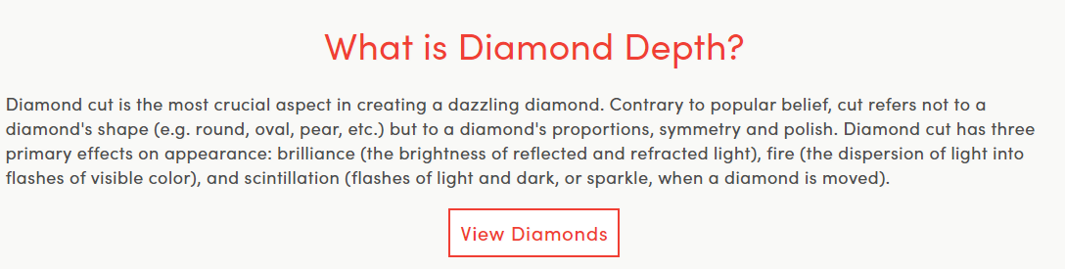

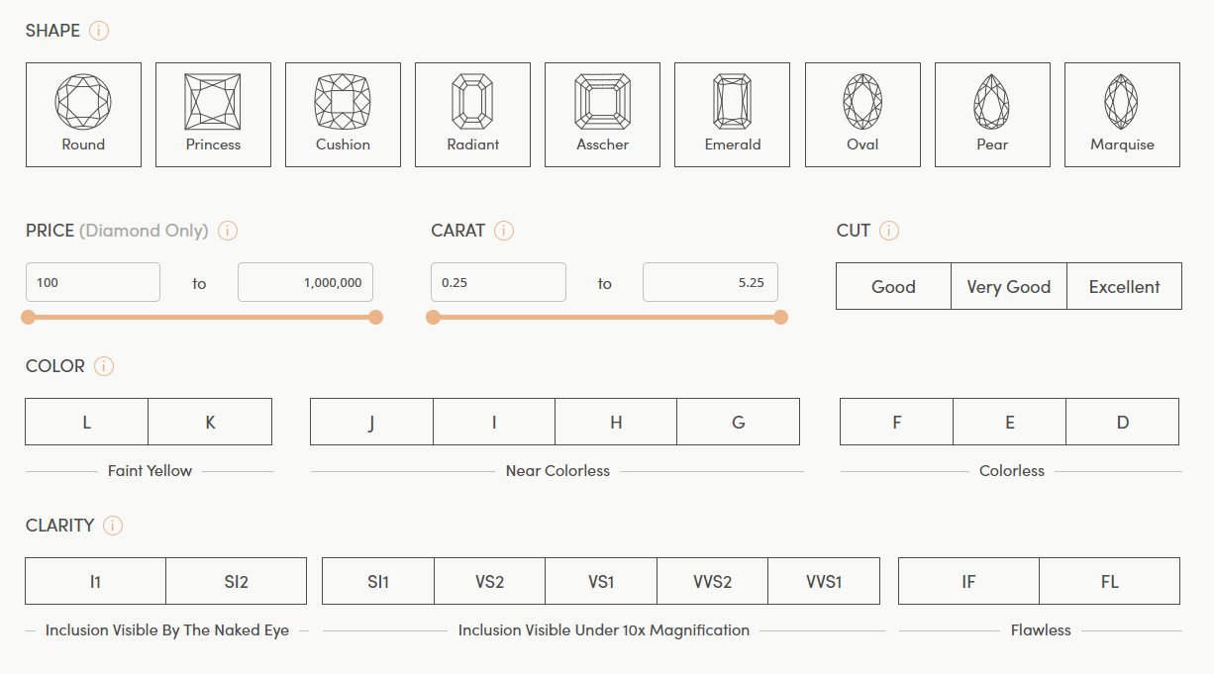

<https://www.withclarity.com/education/diamond-education/diamond-cut/what-is-diamond-depth-or-diamond-education>

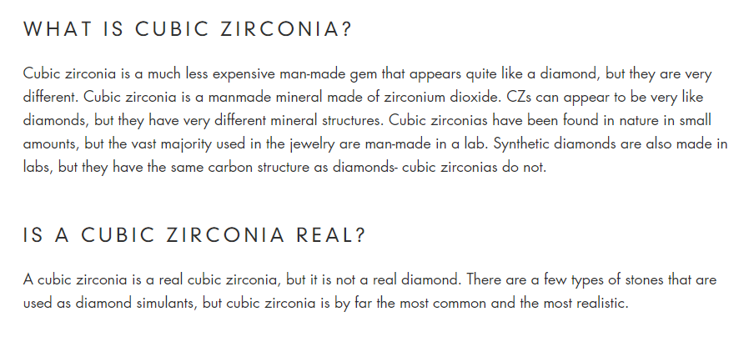

<https://simongjewelry.com/blogs/articles/cubic-zirconia-vs-diamond-how-to-tell-what-is-real>